MY PLACE testing setup - Android

Instructions for users who have an Android based device using **Google Play** to download apps (often Samsung/Sony/HTC). **Note: These instructions are NOT for Council owned tablets – these will automatically receive the app**

1. To receive an invite please access the following URL **on your tablet/phone**:

<https://play.google.com/apps/testing/uk.gov.bathnes.myplace>

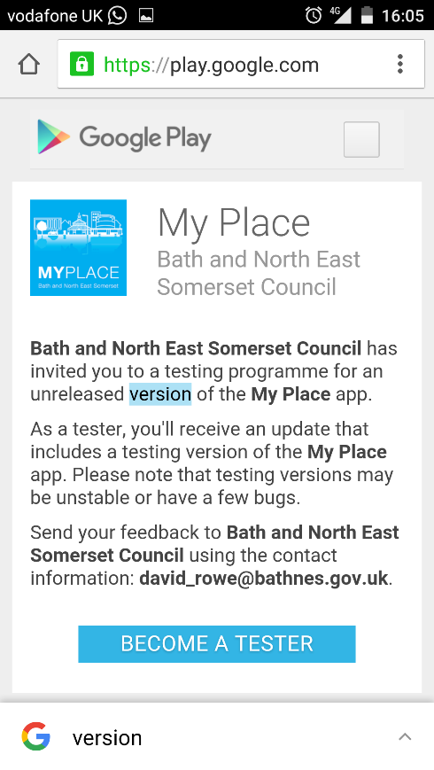

1. You may first be prompted to login to your Google account. Then select the link to Become a tester

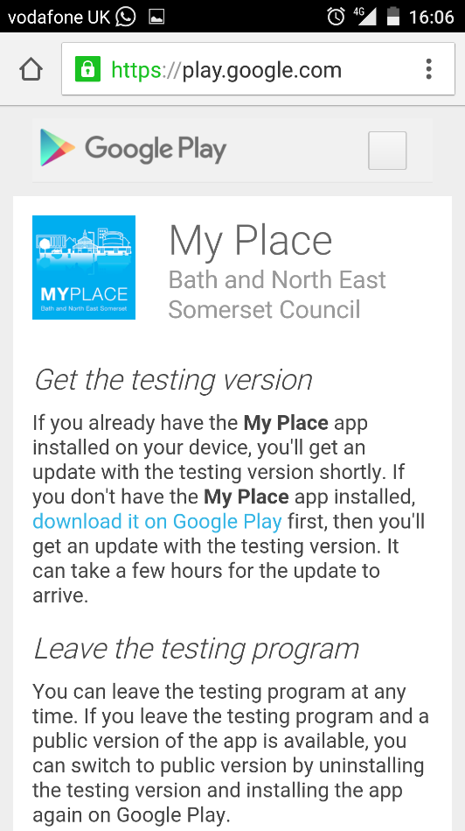

Follow the *‘download it on Google Play’* link. If that link does not immediately work it may be that Google is slow in updating your account to see it – re-try the link a little later (<https://play.google.com/apps/testing/uk.gov.bathnes.myplace>).

1. Click to Install the app.
2. As a registered tester you should receive updates to the app as we release them